What is Memory?
Computer memory can be defined as a collection of some data represented in the binary format. On the basis of various functions, memory can be classified into various categories. We will discuss each one of them later in detail.
A computer device that is capable to store any information or data temporally or permanently, is called storage device.

How Data is being stored in a computer system?
In order to understand memory management, we have to make everything clear about how data is being stored in a computer system.
Machine understands only binary language that is 0 or 1. Computer converts every data into binary language first and then stores it into the memory.
That means if we have a program line written as int α = 10 then the computer converts it into the binary language and then store it into the memory blocks.
The representation of inti = 10 is shown below.
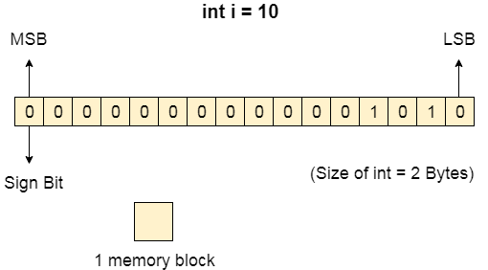
The binary representation of 10 is 1010. Here, we are considering 32 bit system therefore, the size of int is 2 bytes i.e. 16 bit. 1 memory block stores 1 bit. If we are using signed integer then the most significant bit in the memory array is always a signed bit.
Signed bit value 0 represents positive integer while 1 represents negative integer. Here, the range of values that can be stored using the memory array is -32768 to +32767.
well, we can enlarge this range by using unsigned int. in that case, the bit which is now storing the sign will also store the bit value and therefore the range will be 0 to 65,535.

Need for Multi programming
However, The CPU can directly access the main memory, Registers and cache of the system. The program always executes in main memory. The size of main memory affects degree of Multi programming to most of the extant. If the size of the main memory is larger than CPU can load more processes in the main memory at the same time and therefore will increase degree of Multi programming as well as CPU utilization.
- Let's consider,
- Process Size = 4 MB
- Main memory size = 4 MB
- The process can only reside in the main memory at any time.
- If the time for which the process does IO is P,

- Then,

- CPU utilization = (1-P)
- let's say,
- P = 70%
- CPU utilization = 30 %
- Now, increase the memory size, Let's say it is 8 MB.
- Process Size = 4 MB
- Two processes can reside in the main memory at the same time.
- Let's say the time for which, one process does its IO is P,

- Then

- CPU utilization = (1-P^2)
- let's say P = 70 %
- CPU utilization = (1-0.49) =0.51 = 51 %
Therefore, we can state that the CPU utilization will be increased if the memory size gets increased.

Fixed Partitioning
The earliest and one of the simplest technique which can be used to load more than one processes into the main memory is Fixed partitioning or Contiguous memory allocation.
In this technique, the main memory is divided into partitions of equal or different sizes. The operating system always resides in the first partition while the other partitions can be used to store user processes. The memory is assigned to the processes in contiguous way.
In fixed partitioning,
- The partitions cannot overlap.
- A process must be contiguously present in a partition for the execution.
There are various cons of using this technique.
1. Internal Fragmentation
If the size of the process is lesser then the total size of the partition then some size of the partition get wasted and remain unused. This is wastage of the memory and called internal fragmentation.
As shown in the image below, the 4 MB partition is used to load only 3 MB process and the remaining 1 MB got wasted.
2. External Fragmentation
The total unused space of various partitions cannot be used to load the processes even though there is space available but not in the contiguous form.
As shown in the image below, the remaining 1 MB space of each partition cannot be used as a unit to store a 4 MB process. Despite of the fact that the sufficient space is available to load the process, process will not be loaded.
3. Limitation on the size of the process
If the process size is larger than the size of maximum sized partition then that process cannot be loaded into the memory. Therefore, a limitation can be imposed on the process size that is it cannot be larger than the size of the largest partition.
4. Degree of multiprogramming is less
By Degree of multi programming, we simply mean the maximum number of processes that can be loaded into the memory at the same time. In fixed partitioning, the degree of multiprogramming is fixed and very less due to the fact that the size of the partition cannot be varied according to the size of processes.
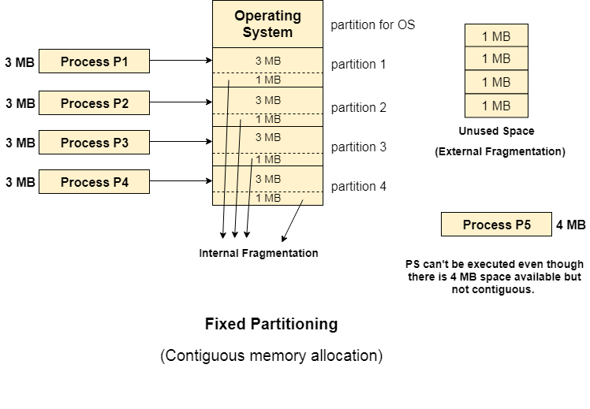
Next TopicDynamic Partitioning

Dynamic Partitioning
Dynamic partitioning tries to overcome the problems caused by fixed partitioning. In this technique, the partition size is not declared initially. It is declared at the time of process loading.
The first partition is reserved for the operating system. The remaining space is divided into parts. The size of each partition will be equal to the size of the process. The partition size varies according to the need of the process so that the internal fragmentation can be avoided.
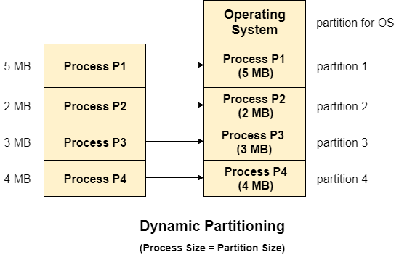

Advantages of Dynamic Partitioning over fixed partitioning

1. No Internal Fragmentation
Given the fact that the partitions in dynamic partitioning are created according to the need of the process, It is clear that there will not be any internal fragmentation because there will not be any unused remaining space in the partition.

2. No Limitation on the size of the process
In Fixed partitioning, the process with the size greater than the size of the largest partition could not be executed due to the lack of sufficient contiguous memory. Here, In Dynamic partitioning, the process size can't be restricted since the partition size is decided according to the process size.

3. Degree of multiprogramming is dynamic
Due to the absence of internal fragmentation, there will not be any unused space in the partition hence more processes can be loaded in the memory at the same time.

Disadvantages of dynamic partitioning

External Fragmentation
Absence of internal fragmentation doesn't mean that there will not be external fragmentation.
Let's consider three processes P1 (1 MB) and P2 (3 MB) and P3 (1 MB) are being loaded in the respective partitions of the main memory.
After some time P1 and P3 got completed and their assigned space is freed. Now there are two unused partitions (1 MB and 1 MB) available in the main memory but they cannot be used to load a 2 MB process in the memory since they are not contiguously located.
The rule says that the process must be contiguously present in the main memory to get executed. We need to change this rule to avoid external fragmentation.
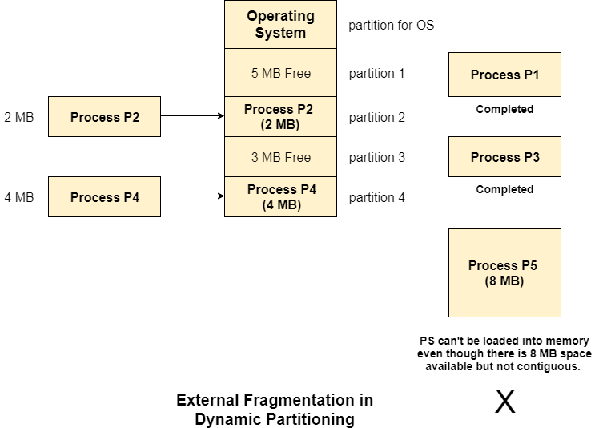

Complex Memory Allocation
In Fixed partitioning, the list of partitions is made once and will never change but in dynamic partitioning, the allocation and deallocation is very complex since the partition size will be varied every time when it is assigned to a new process. OS has to keep track of all the partitions.
Due to the fact that the allocation and deallocation are done very frequently in dynamic memory allocation and the partition size will be changed at each time, it is going to be very difficult for OS to manage everything.

Fragmentation in Operating System
Fragmentation is an unwanted problem in the operating system in which the processes are loaded and unloaded from memory, and free memory space is fragmented. Processes can't be assigned to memory blocks due to their small size, and the memory blocks stay unused.
Contiguous memory allocation allocates space to processes whenever the processes enter RAM. These RAM spaces are divided either by fixed partitioning or by dynamic partitioning. As the process is loaded and unloaded from memory, these areas are fragmented into small pieces of memory that cannot be allocated to coming processes.
In this article, you will learn about fragmentation and its types.

What is Fragmentation?
Fragmentation is an unwanted problem in the operating system in which the processes are loaded and unloaded from memory, and free memory space is fragmented. Processes can't be assigned to memory blocks due to their small size, and the memory blocks stay unused. It is also necessary to understand that as programs are loaded and deleted from memory, they generate free space or a hole in the memory. These small blocks cannot be allotted to new arriving processes, resulting in inefficient memory use.
The conditions of fragmentation depend on the memory allocation system. As the process is loaded and unloaded from memory, these areas are fragmented into small pieces of memory that cannot be allocated to incoming processes. It is called fragmentation.

Causes of Fragmentation
User processes are loaded and unloaded from the main memory, and processes are kept in memory blocks in the main memory. Many spaces remain after process loading and swapping that another process cannot load due to their size. Main memory is available, but its space is insufficient to load another process because of the dynamical allocation of main memory processes.

Types of Fragmentation
There are mainly two types of fragmentation in the operating system. These are as follows:
- Internal Fragmentation
- External Fragmentation

Internal Fragmentation
When a process is allocated to a memory block, and if the process is smaller than the amount of memory requested, a free space is created in the given memory block. Due to this, the free space of the memory block is unused, which causes internal fragmentation.
For Example:
Assume that memory allocation in RAM is done using fixed partitioning (i.e., memory blocks of fixed sizes). 2MB, 4MB, 4MB, and 8MB are the available sizes. The Operating System uses a part of this RAM.
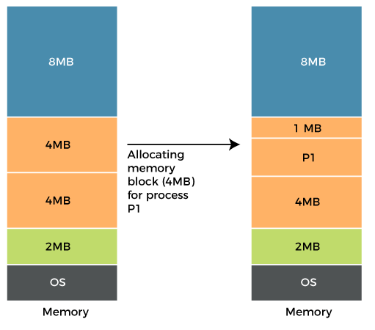
Let's suppose a process P1 with a size of 3MB arrives and is given a memory block of 4MB. As a result, the 1MB of free space in this block is unused and cannot be used to allocate memory to another process. It is known as internal fragmentation.
How to avoid internal fragmentation?
The problem of internal fragmentation may arise due to the fixed sizes of the memory blocks. It may be solved by assigning space to the process via dynamic partitioning. Dynamic partitioning allocates only the amount of space requested by the process. As a result, there is no internal fragmentation.

External Fragmentation
External fragmentation happens when a dynamic memory allocation method allocates some memory but leaves a small amount of memory unusable. The quantity of available memory is substantially reduced if there is too much external fragmentation. There is enough memory space to complete a request, but it is not contiguous. It's known as external fragmentation.
For Example:
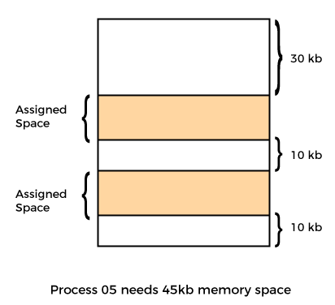
Let's take the example of external fragmentation. In the above diagram, you can see that there is sufficient space (50 KB) to run a process (05) (need 45KB), but the memory is not contiguous. You can use compaction, paging, and segmentation to use the free space to execute a process.
How to remove external fragmentation?
This problem occurs when you allocate RAM to processes continuously. It is done in paging and segmentation, where memory is allocated to processes non-contiguously. As a result, if you remove this condition, external fragmentation may be decreased.
Compaction is another method for removing external fragmentation. External fragmentation may be decreased when dynamic partitioning is used for memory allocation by combining all free memory into a single large block. The larger memory block is used to allocate space based on the requirements of the new processes. This method is also known as defragmentation.

Advantages and disadvantages of fragmentation
There are various advantages and disadvantages of fragmentation. Some of them are as follows:

Advantages
There are various advantages of fragmentation. Some of them are as follows:
Fast Data Writes
Data write in a system that supports data fragmentation may be faster than reorganizing data storage to enable contiguous data writes.
Fewer Failures
If there is insufficient sequential space in a system that does not support fragmentation, the write will fail.
Storage Optimization
A fragmented system might potentially make better use of a storage device by utilizing every available storage block.

Disadvantages
There are various disadvantages of fragmentation. Some of them are as follows:
Need for regular defragmentation
A more fragmented storage device's performance will degrade with time, necessitating the requirement for time-consuming defragmentation operations.
Slower Read Times
The time it takes to read a non-sequential file might increase as a storage device becomes more fragmented.

Conclusion
In short, both internal and external fragmentation are natural processes that result in either memory wasting or empty memory space. However, the problems in both cases cannot be completely overcome, although they can be reduced to some extent using the solutions provided above.

What is Virtual Memory in OS (Operating System)?
Virtual Memory is a storage scheme that provides user an illusion of having a very big main memory. This is done by treating a part of secondary memory as the main memory.
In this scheme, User can load the bigger size processes than the available main memory by having the illusion that the memory is available to load the process.
Instead of loading one big process in the main memory, the Operating System loads the different parts of more than one process in the main memory.
By doing this, the degree of multiprogramming will be increased and therefore, the CPU utilization will also be increased.
Backward Skip 10sPlay VideoForward Skip 10s

How Virtual Memory Works?
In modern word, virtual memory has become quite common these days. In this scheme, whenever some pages needs to be loaded in the main memory for the execution and the memory is not available for those many pages, then in that case, instead of stopping the pages from entering in the main memory, the OS search for the RAM area that are least used in the recent times or that are not referenced and copy that into the secondary memory to make the space for the new pages in the main memory.
Since all this procedure happens automatically, therefore it makes the computer feel like it is having the unlimited RAM.

Demand Paging
Demand Paging is a popular method of virtual memory management. In demand paging, the pages of a process which are least used, get stored in the secondary memory.
A page is copied to the main memory when its demand is made or page fault occurs. There are various page replacement algorithms which are used to determine the pages which will be replaced. We will discuss each one of them later in detail.

Snapshot of a virtual memory management system
Let us assume 2 processes, P1 and P2, contains 4 pages each. Each page size is 1 KB. The main memory contains 8 frame of 1 KB each. The OS resides in the first two partitions. In the third partition, 1st page of P1 is stored and the other frames are also shown as filled with the different pages of processes in the main memory.
The page tables of both the pages are 1 KB size each and therefore they can be fit in one frame each. The page tables of both the processes contain various information that is also shown in the image.
The CPU contains a register which contains the base address of page table that is 5 in the case of P1 and 7 in the case of P2. This page table base address will be added to the page number of the Logical address when it comes to accessing the actual corresponding entry.
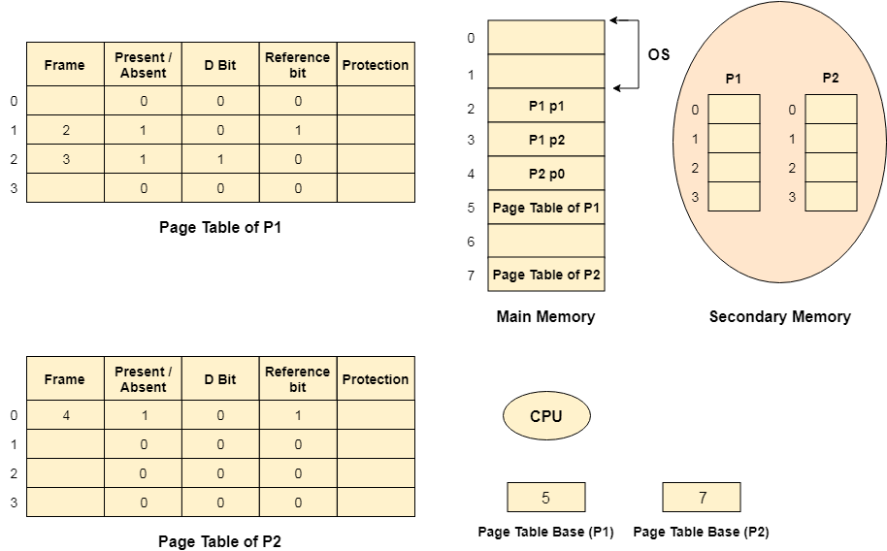

Advantages of Virtual Memory
- The degree of Multiprogramming will be increased.
- User can run large application with less real RAM.
- There is no need to buy more memory RAMs.

Disadvantages of Virtual Memory
- The system becomes slower since swapping takes time.
- It takes more time in switching between applications.
- The user will have the lesser hard disk space for its use.

hat are Demand Paging and Pre-paging?
According to the concept of virtual memory, the entire process doesn't need to be loaded into the main memory to execute any process at the given time. The process can be executed efficiently if only some of the pages are present in the main memory at a particular time. But, the problem here is how we decide the basis of the selection of pages to be loaded into the main memory for execution of a process beforehand. It means which page should be present in the main memory at a particular time and which one should not be there.
To resolve this problem, here is a concept of demand paging in an operating system. This concept says we should not load any page into the main memory until required or keep all the pages in secondary memory until demanded. In contrast, in Pre-Paging, the OS guess in advance which page the process will require and pre-loads them into the memory.
The concept of Pre-paging is used to reduce the large number of page faults that occur at the start of a process where the basic strategy is to bring all the pages into the memory that will be needed at the same time before the process references them.

What is Demand Paging in OS?
Demand paging is a technique used in virtual memory systems where the pages are brought in the main memory only when required or demanded by the CPU. Hence, it is also called lazy swapper because the swapping of pages is done only when the CPU requires it. Virtual memory is commonly implemented in demand paging.
Backward Skip 10sPlay VideoForward Skip 10s
In demand paging, the pager brings only those necessary pages into the memory instead of swapping in a whole process. Thus, demand paging avoids reading into memory pages that will not be used anyways, decreasing the swap time and the amount of physical memory needed.

How does Demand Paging Work?
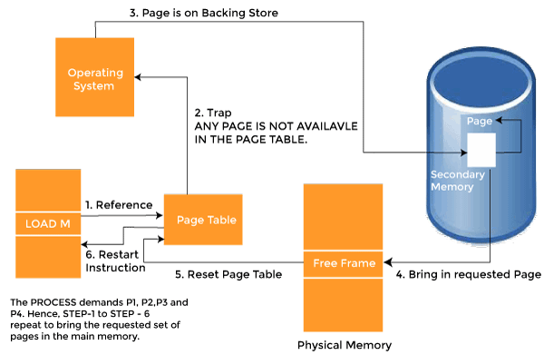
The demand paging system depends on the page table implementation because the page table helps map logical memory to physical memory. Bitwise operators are implemented in the page table to indicate that pages are ok or not (valid or invalid). All valid pages exist in primary memory, and invalid pages exist in secondary memory. Now all processes go-ahead to access all pages, and then the following things will be happened, such as:
- Attempt to currently access page.
- If the page is ok (Valid), then all processing instructions work as normal.
- If anyone's page is found invalid, then a page fault issue arises.
- Now memory reference is determined whether a valid reference exists on the auxiliary memory or not. If not exist, then the process is terminated, otherwise needed pages are paged in.
- Now disk operations are implemented to fetch the required page into primary memory.

Examples of Demand Paging
Suppose we have to execute a process P having four pages P0, P1, P2, and P3. Currently, in the page table, we have pages P1 and P3.
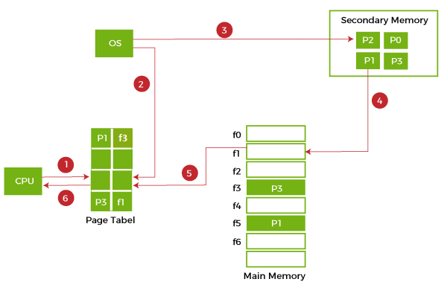
- If the CPU wants to access page P2 of a process P, it will first search the page in the page table.
- As the page table does not contain this page so it will be a trapor page fault. The control goes to the operating system as soon as the trap is generated and context switching happens.
- The OS system will put the process in a waiting/ blocked state. The OS system will now search that page in the backing store or secondary memory.
- The OS will then read the page from the backing store and load it to the main memory.
- Next, the OS system will update the page table entry accordingly.
- Finally, the control is taken back from the OS, and the execution of the process is resumed.
Hence, the operating system follows these steps whenever a page fault occurs and the required page is brought into memory.
So whenever a page fault occurs, as shown in all the above steps 2 to 6. This time taken to service the page fault is called the Page fault service time.
Effective Memory Access Time: When the page fault rate is 'p' while executing any process, then the effective memory access time is calculated as follows:
Effective Memory Access time = (p)*(s) + (1-p)*(m)
Where
- p is the page fault rate.
- s is the page fault service time.
- m is the main memory access time.

NOTE: EAT direct proportional to the page fault rate.

Advantages of Demand Paging
Here are the following advantages of demand paging in the operating system, such as:
- It increases the degree of multiprogramming as many processes can be present in the main memory simultaneously.
- There is a more efficient use of memory as processes having a size more than the size of the main memory can also be executed using this mechanism because we are not loading the whole page at a time.
- We have to the right for scaling of virtual memory.
- If any program is larger than physical memory, it helps run this program without compaction.
- Partition management is simpler.
- It is more useful in a time-sharing system.
- It has no limitations on the level of multi-programming.
- Discards external fragmentation.
- Easy to swap all pages.

Disadvantages of Demand Paging
Below are some disadvantages of demand paging in an operating system, such as:
- The amount of processor overhead and the number of tables used for handling the page faults is greater than in simple page management techniques.
- It has more probability of internal fragmentation.
- Its memory access time is longer.
- Page Table Length Register (PTLR) has a limit for virtual memory.
- Page map table is needed additional memory and registers.

What is Pre-paging in OS?
Pre-paging is used to overcome a major drawback of demand paging. A major drawback of demand paging is many page faults, which may occur as soon as a process starts to execute. The situation results from an effort to load the initial locality into memory, and the same situation may arise repeatedly.
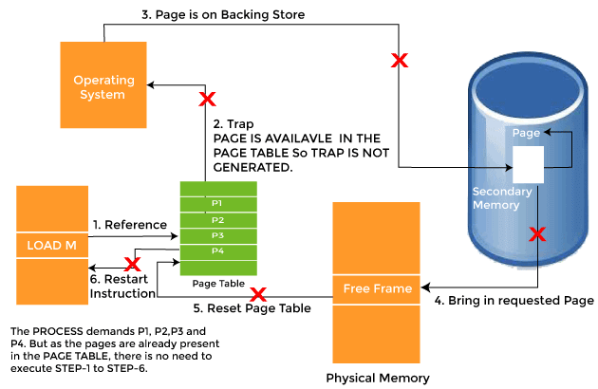
For example, when a process is restarted after being swapped out, all its pages are present on the disk, and hence each of the pages must be brought back to the main memory for execution of the process by its own page fault the worst case.
If a system uses a Working Set Model, a list of pages is maintained with each process in its working set. If a process is suspended due to a lack of free frames or an I/O wait, the working set of the process is not lost. When a process is resumed, the entire working set is brought back into the memory before the process begins to execute again.
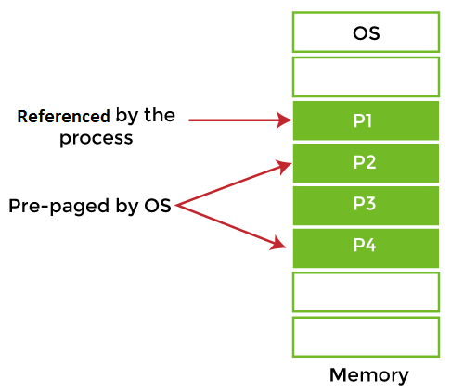
The above diagram shows that only one page was referenced or demanded by the CPU, but three more pages were pre-paged by the OS. The OS tries to predict which page would be next required by the processor and brings that page proactively into the main memory.
The major advantage of Pre-paging is that it might save time when a process references consecutive addresses. In this case, it is easy for the operating system to guess and load the appropriate pages, and, as there is a high probability of the guess being right for many pages, fewer page faults will occur.
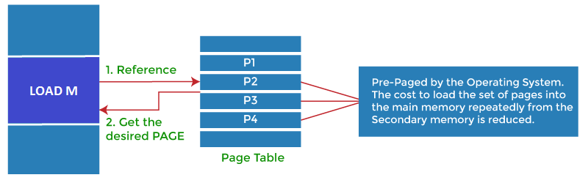
Pre-paging may not always be beneficial. The advantage of Pre-paging is based on the answer to a simple question: whether the cost of implementing Pre-paging is less than the cost of servicing the corresponding page faults. It may be the case that a considerably large number of pages brought back into the memory by Pre-paging are not used. The disadvantage of the concept is that there is wastage of resources like time and memory if the pre-loaded pages are unused.

Advantages of Pre-paging
In an operating system, pre-paging has the following advantages, such as:
- It saves time when large contiguous structures are used. Consider anexample where the process requests consecutive addresses. So, in such cases, the operating system can guess the next pages. And, if the guesses are right, fewer page faults will occur, and the effective memory access time will increase.

Disadvantages of Pre-paging
Pre-paging also has the following disadvantages, such as:
- There is wastage of time and memory if those pre-paged pages are unused.

Difference between Demand Paging and Pre-paging
In demand paging, only those pages are brought into the main memory required to execute the program. When a program needs other pages, it will swap out the unused pages from the main memory and swap in the desired page. Thus, allowing it to execute the program through the space available is insufficient to bring the whole program into the main memory. One of the problems that arise due to demand paging is page fault which is caused due to the required page not being found in the main memory for which we require swapping.
In pre-paging, pages other than the one demanded by a page fault are brought in. The selection of such pages is done based on common access patterns, especially for secondary memory devices. Below are some more differences between the demand paging and pre-paging, such as:
Demand Paging | Pre-paging
Any page is not loaded into the main memory unless the process is referencing it at the present instant. | All the pages are loaded into the memory that will be needed simultaneously but before the process actually references them.
The number of page faults is significantly high. | The number of page faults may be reduced in certain specific cases.
The time taken to load the pages cannot decrease in any situation. | The time taken to load the pages decreases when a process references consecutive addresses.
The pages loaded in the main memory are certainly used. | The pages loaded in the main memory might or might not be used.
There is no wastage of resources as a page is loaded as and when needed. | There is wastage of resources as there is a high chance that the pages might be unused.

Page Fault Handling in Operating System
In this article, you will learn about page fault handling in the operating system and its steps.

What is Page Fault in Operating System?
Page faults dominate more like an error. A page fault will happen if a program tries to access a piece of memory that does not exist in physical memory (main memory). The fault specifies the operating system to trace all data into virtual memory management and then relocate it from secondary memory to its primary memory, such as a hard disk.
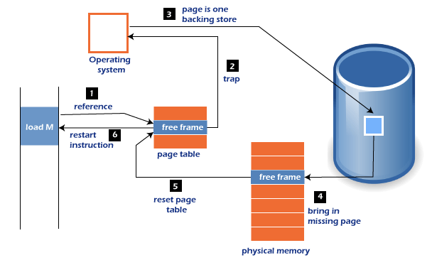
A page fault trap occurs if the requested page is not loaded into memory. The page fault primarily causes an exception, which is used to notify the operating system to retrieve the "pages" from virtual memory to continue operation. Once all of the data has been placed into physical memory, the program resumes normal operation. The Page fault process occurs in the background, and thus the user is unaware of it.
- The computer's hardware track to the kernel and the program counter is often saved on the stack. The CPU registers hold information about the current state of instruction.
- An assembly program is started, which saves the general registers and other volatile data to prevent the Operating system from destroying it.

Page Fault Handling
A Page Fault happens when you access a page that has been marked as invalid. The paging hardware would notice that the invalid bit is set while translating the address across the page table, which will cause an operating system trap. The trap is caused primarily by the OS's failure to load the needed page into memory.
Now, let's understand the procedure of page fault handling in the OS:
- Firstly, an internal table for this process to assess whether the reference was valid or invalid memory access.
- If the reference becomes invalid, the system process would be terminated. Otherwise, the page will be paged in.
- After that, the free-frame list finds the free frame in the system.
- Now, the disk operation would be scheduled to get the required page from the disk.
- When the I/O operation is completed, the process's page table will be updated with a new frame number, and the invalid bit will be changed. Now, it is a valid page reference.
- If any page fault is found, restart these steps from starting.

Page Fault Terminology
There are various page fault terminologies in the operating system. Some terminologies of page fault are as follows:
1. Page Hit
When the CPU attempts to obtain a needed page from main memory and the page exists in main memory (RAM), it is referred to as a "PAGE HIT".
2. Page Miss
If the needed page has not existed in the main memory (RAM), it is known as "PAGE MISS".
3. Page Fault Time
The time it takes to get a page from secondary memory and recover it from the main memory after loading the required page is known as "PAGE FAULT TIME".
4. Page Fault Delay
The rate at which threads locate page faults in memory is referred to as the "PAGE FAULT RATE". The page fault rate is measured per second.
5. Hard Page Fault
If a required page exists in the hard disk's page file, it is referred to as a "HARD PAGE FAULT".
6. Soft Page Fault
If a required page is not located on the hard disk but is found somewhere else in memory, it is referred to as a "SOFT PAGE FAULT".
7. Minor Page Fault
If a process needs data and that data exists in memory but is being allotted to another process at the same moment, it is referred to as a "MINOR PAGE FAULT".

Page Replacement Algorithms in Operating Systems (OS)
Today we are going to learn about Page Replacement Algorithms in Operating Systems (OS). Before knowing about Page Replacement Algorithms in Operating Systems let us learn about Paging in Operating Systems and also a little about Virtual Memory.
Only after understanding the concept of Paging we will understand about Page Replacement Algorithms.

Paging in Operating Systems (OS)
Paging is a storage mechanism. Paging is used to retrieve processes from secondary memory to primary memory.
The main memory is divided into small blocks called pages. Now, each of the pages contains the process which is retrieved into main memory and it is stored in one frame of memory.
It is very important to have pages and frames which are of equal sizes which are very useful for mapping and complete utilization of memory.

Virtual Memory in Operating Systems (OS)
A storage method known as virtual memory gives the user the impression that their main memory is quite large. By considering a portion of secondary memory as the main memory, this is accomplished.
By giving the user the impression that there is memory available to load the process, this approach allows them to load larger size programs than the primary memory that is accessible.
The Operating System loads the many components of several processes in the main memory as opposed to loading a single large process there.
By doing this, the level of multiprogramming will be enhanced, which will increase CPU consumption.

Demand Paging
The Demand Paging is a condition which is occurred in the Virtual Memory. We know that the pages of the process are stored in secondary memory. The page is brought to the main memory when required. We do not know when this requirement is going to occur. So, the pages are brought to the main memory when required by the Page Replacement Algorithms.
So, the process of calling the pages to main memory to secondary memory upon demand is known as Demand Paging.
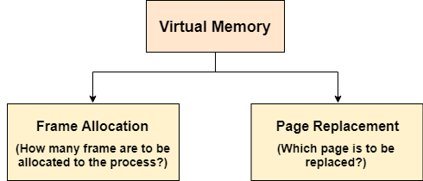
The important jobs of virtual memory in Operating Systems are two. They are:
- Frame Allocation
- Page Replacement.

Frame Allocation in Virtual Memory
Demand paging is used to implement virtual memory, an essential component of operating systems. A page-replacement mechanism and a frame allocation algorithm must be created for demand paging. If you have numerous processes, frame allocation techniques are utilized to determine how many frames to provide to each process.
A Physical Address is required by the Central Processing Unit (CPU) for the frame creation and the physical Addressing provides the actual address to the frame created. For each page a frame must be created.

Frame Allocation Constraints
- The Frames that can be allocated cannot be greater than total number of frames.
- Each process should be given a set minimum amount of frames.
- When fewer frames are allocated then the page fault ration increases and the process execution becomes less efficient
- There ought to be sufficient frames to accommodate all the many pages that a single instruction may refer to

Frame Allocation Algorithms
There are three types of Frame Allocation Algorithms in Operating Systems. They are:
1) Equal Frame Allocation Algorithms
Here, in this Frame Allocation Algorithm we take number of frames and number of processes at once. We divide the number of frames by number of processes. We get the number of frames we must provide for each process.
This means if we have 36 frames and 6 processes. For each process 6 frames are allocated.
It is not very logical to assign equal frames to all processes in systems with processes of different sizes. A lot of allocated but unused frames will eventually be wasted if a lot of frames are given to a little operation.
2) Proportionate Frame Allocation Algorithms
Here, in this Frame Allocation Algorithms we take number of frames based on the process size. For big process more number of frames is allocated. For small processes less number of frames is allocated by the operating system.
The problem in the Proportionate Frame Allocation Algorithm is number of frames are wasted in some rare cases.
The advantage in Proportionate Frame Allocation Algorithm is that instead of equally, each operation divides the available frames according to its demands.
3) Priority Frame Allocation Algorithms
According to the quantity of frame allocations and the processes, priority frame allocation distributes frames. Let's say a process has a high priority and needs more frames; in such case, additional frames will be given to the process. Processes with lower priorities are then later executed in future and first only high priority processes are executed first.

Page Replacement Algorithms
There are three types of Page Replacement Algorithms. They are:
- Optimal Page Replacement Algorithm
- First In First Out Page Replacement Algorithm
- Least Recently Used (LRU) Page Replacement Algorithm

First in First out Page Replacement Algorithm
This is the first basic algorithm of Page Replacement Algorithms. This algorithm is basically dependent on the number of frames used. Then each frame takes up the certain page and tries to access it. When the frames are filled then the actual problem starts. The fixed number of frames is filled up with the help of first frames present. This concept is fulfilled with the help of Demand Paging
After filling up of the frames, the next page in the waiting queue tries to enter the frame. If the frame is present then, no problem is occurred. Because of the page which is to be searched is already present in the allocated frames.
If the page to be searched is found among the frames then, this process is known as Page Hit.
If the page to be searched is not found among the frames then, this process is known as Page Fault.
When Page Fault occurs this problem arises, then the First In First Out Page Replacement Algorithm comes into picture.
The First In First Out (FIFO) Page Replacement Algorithm removes the Page in the frame which is allotted long back. This means the useless page which is in the frame for a longer time is removed and the new page which is in the ready queue and is ready to occupy the frame is allowed by the First In First Out Page Replacement.
Let us understand this First In First Out Page Replacement Algorithm working with the help of an example.
Example:
Consider the reference string 6, 1, 1, 2, 0, 3, 4, 6, 0, 2, 1, 2, 1, 2, 0, 3, 2, 1, 2, 0 for a memory with three frames and calculate number of page faults by using FIFO (First In First Out) Page replacement algorithms.
Points to Remember
Page Not Found - - - > Page Fault
Page Found - - - > Page Hit
Reference String:
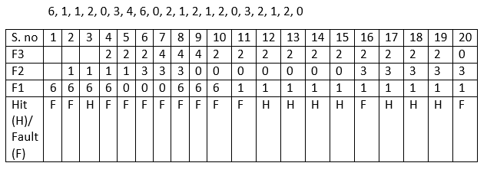
Number of Page Hits = 8
Number of Page Faults = 12
The Ratio of Page Hit to the Page Fault = 8 : 12 - - - > 2 : 3 - - - > 0.66
The Page Hit Percentage = 8 *100 / 20 = 40%
The Page Fault Percentage = 100 - Page Hit Percentage = 100 - 40 = 60%
Explanation
First, fill the frames with the initial pages. Then, after the frames are filled we need to create a space in the frames for the new page to occupy. So, with the help of First in First Out Page Replacement Algorithm we remove the frame which contains the page is older among the pages. By removing the older page we give access for the new frame to occupy the empty space created by the First in First out Page Replacement Algorithm.

OPTIMAL Page Replacement Algorithm
This is the second basic algorithm of Page Replacement Algorithms. This algorithm is basically dependent on the number of frames used. Then each frame takes up the certain page and tries to access it. When the frames are filled then the actual problem starts. The fixed number of frames is filled up with the help of first frames present. This concept is fulfilled with the help of Demand Paging
After filling up of the frames, the next page in the waiting queue tries to enter the frame. If the frame is present then, no problem is occurred. Because of the page which is to be searched is already present in the allocated frames.
If the page to be searched is found among the frames then, this process is known as Page Hit.
If the page to be searched is not found among the frames then, this process is known as Page Fault.
When Page Fault occurs this problem arises, then the OPTIMAL Page Replacement Algorithm comes into picture.
The OPTIMAL Page Replacement Algorithms works on a certain principle. The principle is:
Replace the Page which is not used in the Longest Dimension of time in future
This principle means that after all the frames are filled then, see the future pages which are to occupy the frames. Go on checking for the pages which are already available in the frames. Choose the page which is at last.
Example:
Suppose the Reference String is:
0, 3, 4, 6, 0, 2, 1, 2, 1, 2, 0, 3, 2, 1, 2, 0
6, 1, 2 are in the frames occupying the frames.
Now we need to enter 0 into the frame by removing one page from the page
So, let us check which page number occurs last
From the sub sequence 0, 3, 4, 6, 0, 2, 1 we can say that 1 is the last occurring page number. So we can say that 0 can be placed in the frame body by removing 1 from the frame.
Let us understand this OPTIMAL Page Replacement Algorithm working with the help of an example.
Example:
Consider the reference string 6, 1, 1, 2, 0, 3, 4, 6, 0, 2, 1, 2, 1, 2, 0, 3, 2, 1, 4, 0 for a memory with three frames and calculate number of page faults by using OPTIMAL Page replacement algorithms.
Points to Remember
Page Not Found - - - > Page Fault
Page Found - - - > Page Hit
Reference String:
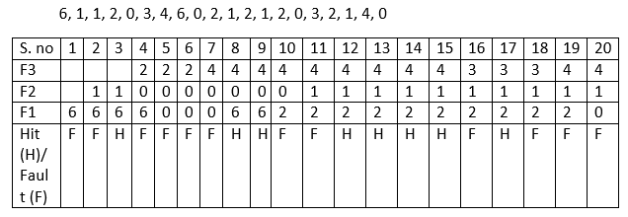
Number of Page Hits = 8
Number of Page Faults = 12
The Ratio of Page Hit to the Page Fault = 8 : 12 - - - > 2 : 3 - - - > 0.66
The Page Hit Percentage = 8 *100 / 20 = 40%
The Page Fault Percentage = 100 - Page Hit Percentage = 100 - 40 = 60%
Explanation
First, fill the frames with the initial pages. Then, after the frames are filled we need to create a space in the frames for the new page to occupy.
Here, we would fill the empty spaces with the pages we and the empty frames we have. The problem occurs when there is no space for occupying of pages. We have already known that we would replace the Page which is not used in the Longest Dimension of time in future.
There comes a question what if there is absence of page which is in the frame.
Suppose the Reference String is:
0, 2, 4, 6, 0, 2, 1, 2, 1, 2, 0, 3, 2, 1, 2, 0
6, 1, 5 are in the frames occupying the frames.
Here, we can see that page number 5 is not present in the Reference String. But the number 5 is present in the Frame. So, as the page number 5 is absent we remove it when required and other page can occupy that position.

Least Recently Used (LRU) Replacement Algorithm
This is the last basic algorithm of Page Replacement Algorithms. This algorithm is basically dependent on the number of frames used. Then each frame takes up the certain page and tries to access it. When the frames are filled then the actual problem starts. The fixed number of frames is filled up with the help of first frames present. This concept is fulfilled with the help of Demand Paging
After filling up of the frames, the next page in the waiting queue tries to enter the frame. If the frame is present then, no problem is occurred. Because of the page which is to be searched is already present in the allocated frames.
If the page to be searched is found among the frames then, this process is known as Page Hit.
If the page to be searched is not found among the frames then, this process is known as Page Fault.
When Page Fault occurs this problem arises, then the Least Recently Used (LRU) Page Replacement Algorithm comes into picture.
The Least Recently Used (LRU) Page Replacement Algorithms works on a certain principle. The principle is:
Replace the page with the page which is less dimension of time recently used page in the past.
Example:
Suppose the Reference String is:
6, 1, 1, 2, 0, 3, 4, 6, 0
The pages with page numbers 6, 1, 2 are in the frames occupying the frames.
Now, we need to allot a space for the page numbered 0.
Now, we need to travel back into the past to check which page can be replaced.
6 is the oldest page which is available in the Frame.
So, replace 6 with the page numbered 0.
Let us understand this Least Recently Used (LRU) Page Replacement Algorithm working with the help of an example.
Example:
Consider the reference string 6, 1, 1, 2, 0, 3, 4, 6, 0, 2, 1, 2, 1, 2, 0, 3, 2, 1, 2, 0 for a memory with three frames and calculate number of page faults by using Least Recently Used (LRU) Page replacement algorithms.
Points to Remember
Page Not Found - - - > Page Fault
Page Found - - - > Page Hit
Reference String:
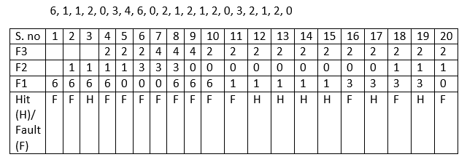
Number of Page Hits = 7
Number of Page Faults = 13
The Ratio of Page Hit to the Page Fault = 7 : 12 - - - > 0.5833 : 1
The Page Hit Percentage = 7 * 100 / 20 = 35%
The Page Fault Percentage = 100 - Page Hit Percentage = 100 - 35 = 65%
Explanation
First, fill the frames with the initial pages. Then, after the frames are filled we need to create a space in the frames for the new page to occupy.
Here, we would fill the empty spaces with the pages we and the empty frames we have. The problem occurs when there is no space for occupying of pages. We have already known that we would replace the Page which is not used in the Longest Dimension of time in past or can be said as the Page which is very far away in the past.

